Create a fault injection rule to delay traffic coming from the test user Jason & confirm

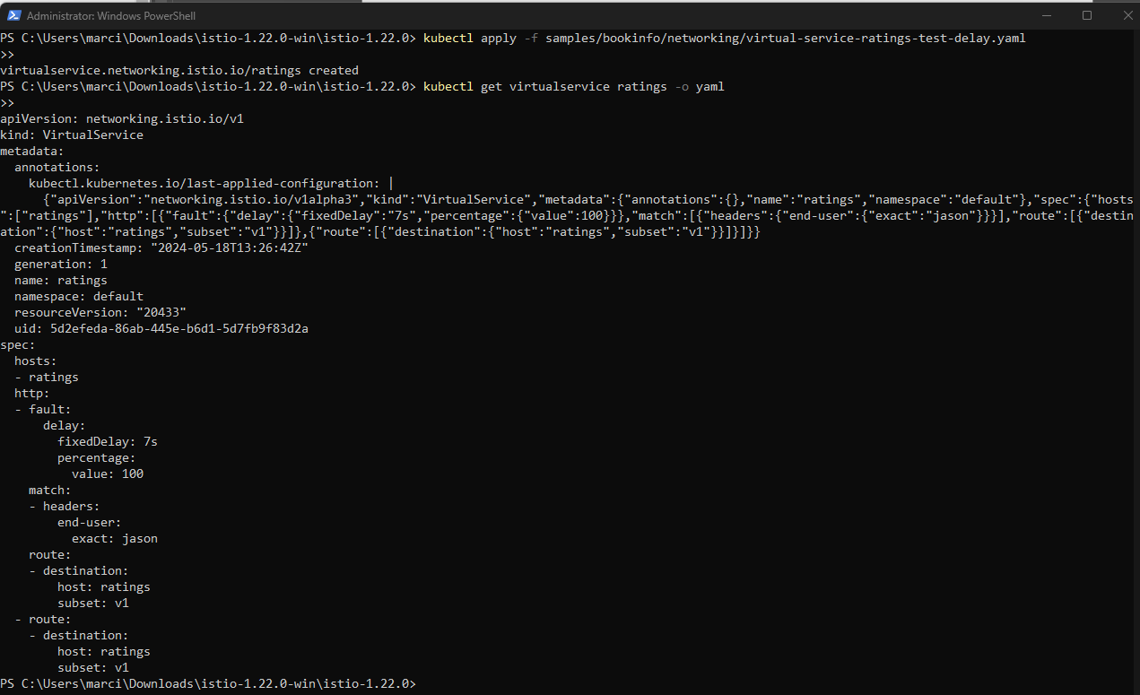

Sign in as Jason (login was delayed)



Open dev tools and reload from ‘network’, (very slow reload)

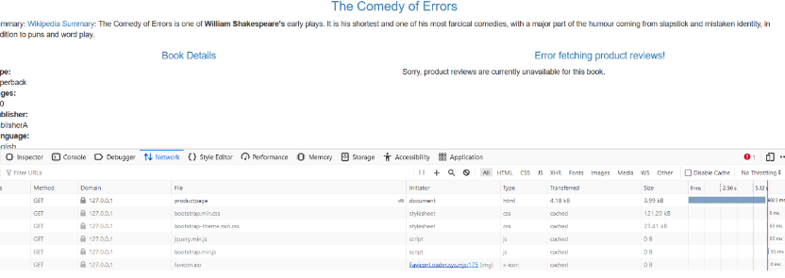

Create a fault injection http abort rule for user ‘jason’ and confirm

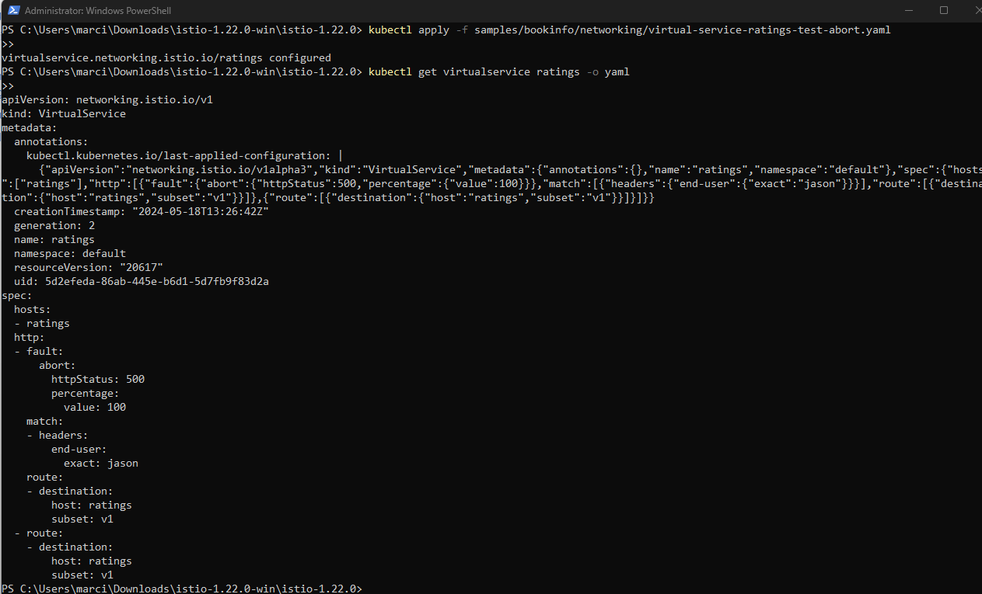

Ratings Service is not available for Jason account

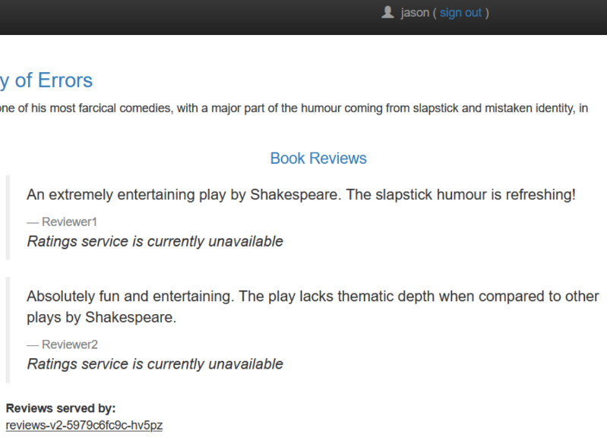

Ratings not served at all to any other users



Remove rules

